Why Do I need to THink About Careers Now?

Much of your adult life will revolve around your work,
very much like your life now revolves around school.

The kind of job you have will affect who you meet, the friends you make, how much time you have for yourself, and the lifestyle you will be able to live.

What do you want your life to look like?

By the time you graduate from high school you will have spent approximately
14,000 hours in school.

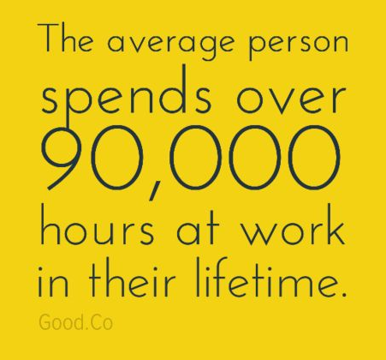

That’s a pretty good reason to spend some time thinking about and planning your career.

How to find the career that is a right fit for you?
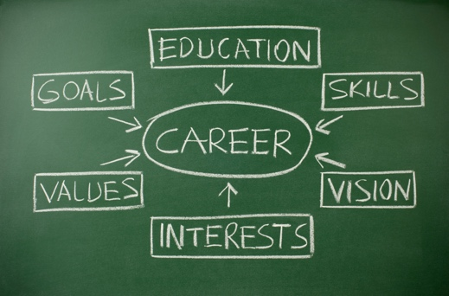
The key is:

- Your interests
- Your abilities
- Your habits
- Your skills
- Your goals

Career Exploration is as much about finding the jobs that are likely to help you be successful and happy as it is about identifying those that are not at good match.
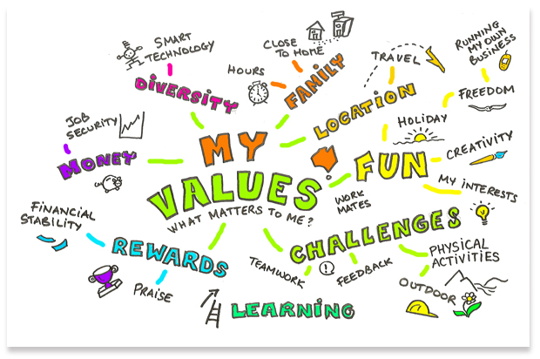
Remember - your interests in the future will probably be different than they are now, but that's okay. In fact, most people will have between 6 to 8 different careers during those 90,000 hours they work. Don't be afraid of change! Determining who you are and what direction you want to go are things that you will continue to do throughout your life. You will have ideas of what you can become good at and like a hypothesis you can test those ideas out by experimenting. If you don't already know your calling, that's normal. It's too hard to predict which career is right for you when you are starting out. Instead go ahead and try things, you will learn as you go.
So, let's begin by answering a few questions about yourself:

    - Name at least one thing that you do better than most of your friends:

    - Name one or more activities that you become so involved in that you lose track of time:

    - What achievements make you most proud?

    - Write down three words you'd use to describe yourself. Then ask someone who knows you well to do the same.

    - Is there anything that you've always dreamed of doing?

Take this Career Cluster Interest Survey to help you discover which clusters fit you.

Directions: Check the items in each box that best describe you. You may make as many or as few checks as you choose. Next, add up the number of checks in each box and put the total for the row in the last box.
Look to see which three rows have the highest numbers. Find the corresponding career clusters on the pages immediately following this survey to see which career clusters you may want to explore.

Source: Adapted from the Guidance Division Survey, Oklahoma Department of Career and Technology Education (2005) and from Minnesota State CAREERwise Education/ Minnesota Department of Education and MnCareers (2017)

 | Activities that describe what I like to do: | Personal qualities that describe me: | School subjects  that I like: | Total number circled
Row 1 | - Learn how things grow and stay alive.  - Make the best use of the earth’s natural resources.  - Hunt and/or ﬁsh.  - Protect the environment.  - Be outdoors in all kinds of weather.  - Plan, budget, and keep records.  - Operate machines and keep them in good repair. | - Self-reliant  - Nature lover  - Physically active  - Planner  - Creative problem solver | - Math  - Biology, Zoology  - Earth Sciences  - Chemistry  - Agriculture | Row 1
Row 2 | - Read and follow blueprints and/or instructions.  - Picture in my mind what a ﬁnished product looks like.  - Work with my hands.  - Perform work that requires precise results.  - Solve technical problems.  - Visit and learn from beautiful, historic, or interesting buildings.  - Follow logical, step-by-step procedures. | - Curious  - Good at following directions  - Pay attention to detail  - Good at seeing possibilities  - Patient and persistent | - Math  - Drafting  - Physical Science  - Chemistry  - Carpentry/ Construction  - Electrical/ Electronics | Row 2
Row 3 | - Use my imagination to communicate new information to others.  - Perform in front of others.  - Read and write.  - Play a musical instrument.  - Perform creative, artistic activities.  - Use video and recording technology.  - Design brochures and posters. | - Creative and imaginative  - Good communicator/good vocabulary  - Curious about new technology  - Relate well to feelings and thoughts of others  - Determined/tenacious | - Art/Graphic design  - Music  - Speech and Drama  - Journalism/  Literature  - Audiovisual Tech | Row 3
Row 4 | - Perform routine, organized activities but can be ﬂexible.  - Work with numbers and detailed information.  - Be the leader in a group.  - Make business contact with people.  - Work with computer programs.  - Create reports and communicate ideas.  - Plan my work and follow instructions without close supervision. | - Organized  - Practical and logical  - Patient  - Tactful  - Responsible | - Computer Applications/ Business and Information Technology  - Accounting  - Math  - Language Arts  - Economics | Row 4
 | Activities that describe what I like to do: | Personal qualities that describe me: | School subjects  that I like: | Total number circled
Row 5 | - Communicate with different types of people.  - Help others with their homework or to learn new things.  - Go to school.  - Direct and plan activities for others.  - Handle several responsibilities at once.  - Acquire new information.  - Help people overcome their challenges. | - Friendly  - Decision maker  - Helpful  - Innovative/Inquisitive  - Good listener | - Language Arts  - Social Studies  - Math  - Science  - Psychology | Row 5
Row 6 | - Work with numbers.  - Work to meet a deadline.  - Make predictions based on existing facts.  - Have a framework of rules by which to operate.  - Analyze ﬁnancial information and interpret it to others.  - Handle money with accuracy and reliability.  - Take pride in the way I dress and look. | - Trustworthy  - Orderly  - Self-conﬁdent  - Logical  - Methodical or efﬁcient | - Accounting  - Math  - Economics  - Banking/  Finance  - Business Law | Row 6
Row 7 | - Be involved in politics.  - Negotiate, defend, and debate ideas and topics.  - Plan activities and work cooperatively with others.  - Work with details.  - Perform a variety of duties that may change often.  - Analyze information and interpret it to others.  - Travel and see things that are new to me. | - Good communicator  - Competitive  - Service minded  - Well organized  - Problem solver | - Government  - Language Arts  - History  - Math  - Foreign Language | Row 7
Row 8 | - Work under pressure.  - Help sick people and animals.  - Make decisions based on logic and information.  - Participate in health and science classes.  - Respond quickly and calmly in emergencies.  - Work as a member of a team.  - Follow guidelines precisely and meet strict standards of accuracy. | - Compassionate and caring  - Good at following directions  - Conscientious and careful  - Patient  - Good listener | - Biology, Zoology  - Chemistry  - Math  - Health  - Language Arts | Row 8
Row 9 | - Investigate new places and activities.  - Work with all ages and types of people.  - Organize activities in which other people enjoy themselves.  - Have a ﬂexible schedule.  - Help people make up their minds.  - Communicate easily, tactfully, and courteously.  - Learn about other cultures. | - Tactful  - Self-motivated  - Works well with others  - Outgoing  - Slow to anger | - Language Arts/Speech  - Foreign Language  - Social Sciences  - Marketing  - Cooking | Row 9
 | Activities that describe what I like to do: | Personal qualities that describe me: | School subjects  that I like: | Total number circled
Row 10 | - Care about people, their needs, and their problems.  - Participate in community services and/or volunteering.  - Listen to other people’s viewpoints.  - Help people be at their best.  - Work with people from preschool age to old age.  - Think of new ways to do things.  - Make friends with different kinds of people. | - Good communicator/ good listener  - Caring  - Non-materialistic  - Uses intuition and logic  - Non-judgmental | - Language Arts  - Psychology/ Sociology  - Family and Consumer Sciences  - Finance  - Foreign Language | Row 10
Row 11 | - Work with computers.  - Reason clearly and logically to solve complex problems.  - Use machines, techniques, and processes.  - Read technical materials and diagrams and solve technical problems.  - Adapt to change.  - Play video games and ﬁgure out how they work.  - Concentrate for long periods without being distracted. | - Logic/analytical thinker  - See details in the big picture  - Persistent  - Good concentration skills  - Precise and accurate | - Math  - Science  - Computer Tech/ Applications  - Communications  - Graphic Design | Row 11
Row 12 | - Work under pressure or in the face of danger.  - Make decisions based on my own observations.  - Interact with other people.  - Be in positions of authority.  - Respect rules and regulations.  - Debate and win arguments.  - Observe and analyze people’s behavior. | - Adventurous  - Dependable  - Community-minded  - Decisive  - Optimistic | - Language Arts  - Psychology/ Sociology  - Government/  History  - Law Enforcement  - First Aid/ Health | Row 12
Row 13 | - Work with my hands and learn that way.  - Put things together.  - Do routine, organized and accurate work.  - Perform activities that produce tangible results.  - Apply math to work out solutions.  - Use hand and power tools and operate equipment/machinery.  - Visualize objects in three dimensions from ﬂat drawings. | - Practical  - Observant  - Physically active  - Step-by-step thinker  - Coordinated | - Math-Geometry  - Chemistry  - Computer Applications  - Technology  - Physics  - Language Arts  - Engineering | Row 13
Row 14 | - Shop and go to the mall.  - Be in charge.  - Make displays and promote ideas.  - Give presentations and enjoy public speaking.  - Persuade people to buy products or to participate in activities.  - Communicate my ideas to other people.  - Take advantage of opportunities to make extra money | - Enthusiastic  - Competitive  - Creative  - Self-motivated  - Persuasive | - Language Arts  - Math  - Business Education/ Marketing  - Economics  - Computer Applications | Row 14
 | Activities that describe what I like to do: | Personal qualities that describe me: | School subjects  that I like: | Total number circled
Row 15 | - Interpret formulas.  - Find the answers to questions.  - Work in a laboratory.  - Figure out how things work and investigate new things.  - Explore new technology.  - Experiment to ﬁnd the best way to do something.  - Pay attention to details and help things be precise. | - Detail oriented  - Inquisitive  - Objective  - Methodical  - Mechanically inclined | - Math  - Science  - Computer-Aided Drafting  - Electronics/ Computer Networking  - Technology | Row 15
Row 16 | - Travel.  - See well and have quick reﬂexes.  - Solve mechanical problems.  - Design efﬁcient processes.  - Anticipate needs and prepare to meet them.  - Drive or ride.  - Move things from one place to another. | - Realistic  - Mechanical  - Coordinated  - Observant  - Planner | - Math  - Construction/ Technology  - Physical Sciences  - Economics  - Foreign Language | Row 16

Terms like career paths, career clusters or career interest areas are a way to describe groups of related careers. Why use career clusters to explore careers and plan your future? Thinking ahead and preparing for careers is helpful if you are headed to the workplace or college. Some careers that are common today may not be needed tomorrow. And all careers require flexibility, knowledge, and skills.
  - Think big. Career clusters help you take a broad look at your options through six career fields and the options within each field.
  - Get excited. Choices seem endless, but remember you're in control. Exploring clusters can get you excited about your options as you discover what's best for you.
  - Save time. Exploring groups of similar occupations helps you select and eliminate choices more quickly than researching many individual occupations.
  - Spend wisely. Make wise decisions about what you're going to study. Don't declare a major quickly and then realize halfway through the program that interests you more.
  - Take control. Base your career choice on your own dreams and interests. Career clusters help you learn about all the types of careers available so you don't leave the decision to chance.
  - Stand out. Grab employers' attention by knowing the skill requirements and knowledge for specific fields and jobs.
Source: careerwise.mnscu.edu
Now let’s look to see which career clusters match your results.
The Sixteen Career Clusters
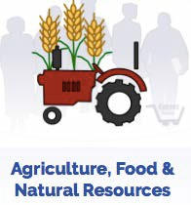  Agriculture, food, and natural resources workers produce agricultural goods. This includes food, plants, animals, fabrics, wood, and crops. You might work on a farm, ranch, dairy, orchard, greenhouse, or plant nursery. You could also work in a clinic or laboratory as a scientist or engineer.  1  Some agriculture, food, and natural resources workers market, sell, or finance agricultural goods. For example, you might market products made from plants and animals. Or, you might sell services that farmers and ranchers use to improve products. You could also work to conserve natural resources or protect the environment | There are many hobbies and activities you could explore to learn more about agriculture, food, and natural resources. Try one or more of these activities:  - Future Farmers of America (FFA)  - Junior Achievement  - Business Professionals of America (BPA)  - 4-H  - Start a recycling project.  - Raise flowers and vegetables to sell at a farmers' market.  - Volunteer at a local animal shelter.  - Work on a farm or ranch.  - Job shadow at a greenhouse
Great Oaks programs offered in this cluster: Animal Science & Management; College Agriculture; Equine Science & Management;
Sustainable Urban Agriculture; Veterinary Assisting; Agriculture Science (Satellite offering at specific partner schools)
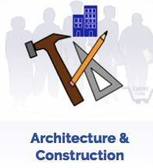  Architecture and construction workers work on buildings and other structures. This includes highways, bridges, houses, and buildings. You might create the designs or plans for new structures. Or, you might use the plans to build it or manage the workers on the project.  2  Some architecture and construction workers do skilled trades, like carpentry, painting, or plumbing. For example, you might do all of the electrical work for a renovated office space. Or, you might work as a landscaper and take care of flowers and trees on large properties. | There are many hobbies and activities you could explore to learn more about architecture and construction. Try one or more of these activities:  - Future Farmers of America (FFA)  - Math Club/Math Counts  - Skills USA  - 4-H  - Start a lawn mowing service.  - Do repair and home improvement projects  - Job shadow at an architecture or home design firm  - Volunteer to care for flowers at a park or community center.
Great Oaks programs offered in this cluster: Commercial & Residential Electricity; Construction Framing & Finishing Technologies;
Construction Technologies; Heating, Ventilating, and Air Conditioning; Heavy Equipment Operations & Engineering

3  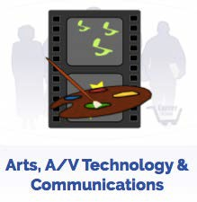  Arts, audio/video technology, and communications workers use creativity and their talents on the job. You might work for an audience as a performer or artist. This includes painters, dancers, sculptors, actors, and singers. Or, you might work behind the scenes to make a performance successful. This includes set designers, editors, broadcast technicians, and camera operators.  Some audio/video technology and communications workers have high-profile jobs. For example, you might work as a news reporter or fashion designer. Or, you might use your creative talents with technology and work as an animator, graphic designer, or film editor. | There are many hobbies and activities you could explore to learn more about arts, audio/video technology, and communications. Try one or more of these activities:  - Volunteer to help with or teach an art, music, or dance community education class.  - Job shadow at an art, photo, or design studio or gallery.  - Intern at a campus radio station, local access cable TV station, web venture, or local newspaper.  - Join the stage crew for a school or community play or concert.  - Band or choir  - Photography  - Speech or debate  - Dance  - Theatre / Drama Club  - School newspaper or yearbook  - Join a community theatre group
Great Oaks programs offered in this cluster: Digital Arts and Design

Business, management, and administrative workers give the support needed to make a business run. You might check employee time records or train new employees. Or, you might work as a top executive and provide the overall direction for a company or department.  4  There are many types of jobs at all levels. For example, you might manage the financial activities of a business, direct the public to specific people or departments, or record incoming and outgoing shipments. | There are many hobbies and activities you could explore to learn more about business management, and administration. Try one or more of these activities:  - Future Farmers of America (FFA)  - Math Club/Math Counts  - Skills USA  - 4-H  - Start a lawn mowing service.  - Do repair and home improvement projects  - Job shadow at an architecture or home design firm  - Volunteer to care for flowers at a park or community center.
Great Oaks programs offered in this cluster: Business Management; High School of Business; (Satellite offering at specific partner schools)

5  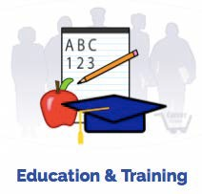  Education and training workers guide and train people.  As a teacher, you could influence young lives. You could also support the work of a classroom teacher as a counselor, librarian, or principal. You could coach sports activities or lead community classes.  You could also work with adults. For example, you could lead training to employees in a business. Or you could work as a university or college professor for undergraduate or graduate students. | There are many hobbies and activities you could explore to learn more about education and training. Try one or more of these activities:  - Business Professionals of America (BPA)  - Future Teachers of America (FTA)  - Coach a sports team.  - Work as a library aid.  - Teach a community education class.  - Tutor a family member or neighbor.  - Coach a local sports team.  - Volunteer at a literacy program.  - Work as a teacher assistant in an elementary or high school.  - Become a part of organizations such as Teammates or Big Brothers/Big Sisters.
Great Oaks programs offered in this cluster: Early Childhood Education; Teaching Professions (Satellite offering at specific partner schools)
6  Finance workers keep track of money. You might work in financial planning, banking, or insurance.  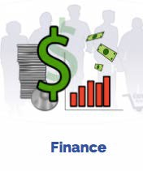  For example, you might provide financial services to a business or individual. Or, you could maintain financial records or give advice to business executives on how to operate their business | There are many hobbies and activities you could explore to learn more about finance. Try one or more of these activities:  - Business Professionals of America (BPA)  - DECA (Marketing association)  - Junior Achievement  - Get elected treasurer of an organization.  - Work in a concession stand.  - Start a business.  - Help with class fundraisers.  - Join a local investment club.  - Manage your own checking account.  - Take a class in personal finance.  - Participate in a financial related activity such as the Stock Market Game.
Great Oaks programs offered in this cluster: High School of Business (Satellite offering at specific partner schools)
Government and public administration workers help pass and enforce the law. You could work in national, state, or local government. You will find almost every type of occupation within the government, including some jobs that are only found within government.  7  For example, you might inspect new or remodeled buildings for safety, help people file the paperwork for a marriage license, or create proposals for urban development. | There are many hobbies and activities you could explore to learn more about government and public administration. Try one or more of these activities:  - Business Professionals of America (BPA)  - Student Council  - Debate  - ROTC  - Participate in mock trial events.  - Work as a page at the legislature.  - Attend city council or other local government meetings.  - Visit a local courthouse or public safety building.  - Job shadow a state legislative representative.  - Run for student government or an organization's board.
Great Oaks programs offered in this cluster: Legal Office Management (Satellite offering at specific partner schools)

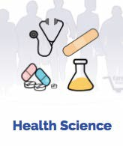  Health science workers promote health and wellness.  8  They diagnose and treat injuries and disease. As a physician, dentist, or nurse, you could work directly with patients. You could also work in a laboratory to get information used in research or provide administrative support by keeping medical records.  Health science jobs are found at a variety of different sites. For example, you could work in a hospital, office, clinic, or nursing home. Or you could work on a cruise ship, at a sports arena, or within a patient's home. | There are many hobbies and activities you could explore to learn more about health services. Try one or more of these activities:  - Health Club  - Science Club  - Skills USA  - Family, Career, and Community Leaders of America (FCCLA)  - Medical Explorers  - Wellness Club  - Health Occupation Students of America (HOSA)  - Attend community health fairs.  - Become involved with your community wellness center.  - Attend a health science camp.  - Volunteer at a hospital or nursing home.  - Work as a student manager on a sports team
Great Oaks programs offered in this cluster: Dental Assisting; Exercise Science & Sports Medicine; Health Technology; Secondary Practical Nursing;
Surgical Technology; Biomedical Science (Satellite offering at specific partner schools)
9  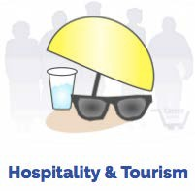  Hospitality and tourism workers help people enjoy vacations and entertainment activities. You might work at a restaurant, resort, sports arena, theme park, museum, or hotel.  For example, you might manage operations of a college cafeteria, guide high school students on a trip to Spain, or rent equipment at a recreation center. |  | There are many hobbies and activities you could explore to learn more about hospitality and tourism. Try one or more of these activities:  - DECA (Marketing association)  - Junior Achievement  - Family, Career, and Community Leaders of America (FCCLA)  - Business Professionals of America (BPA)  - 4-H  - Join a committee to plan an event.  - Join a world language club or conversation circle.  - Help local businesses cater events within the community.  - Work as a student assistant in the school lunch program.  - Plan and cook meals for family, friends, or neighborhood events.  - Take a part-time job in a restaurant, amusement center, or hotel.  - Plan a family vacation.
Great Oaks programs offered in this cluster: Culinary Arts & Hospitality
10  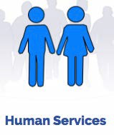  Human services workers help individual and families meet their personal needs. You might work in a government office, hospital, nonprofit agency, nursing home, spa, hotel, or school. Or, you might work in your own home.  For example, you might help students with career and education choices at a high school, cut and color hair in a salon, or manage funeral services at a funeral home. | There are many hobbies and activities you could explore to learn more about human services. Try one or more of these activities  - Family, Career, and Community Leaders of America (FCCLA)  - 4-H  - Future Teachers of America (FTA)  - Volunteer in a soup kitchen or food shelf.  - Visit people who are homebound.  - Provide child care.  - Coordinate a school wide food and/or clothing drive.  - Volunteer in a hospital or nursing home.  - Intern at a nonprofit agency.  - Learn a world language and study foreign cultures.  - Work as a peer counselor or camp counselor.
Great Oaks programs offered in this cluster: Cosmetology
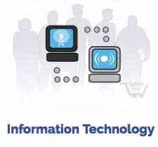  Information technology workers are in a growing and always changing field. You might work with computer hardware, software, multimedia, or network systems. You might design new computer equipment or work on a new computer game.  11  Some information technology workers support and manage computer hardware. For example, you might make sure the networks are working or manage a network that links people across the world. Or, you might support others and answer questions about specific software or hardware. | There are many hobbies and activities you could explore to learn more about information technology. Try one or more of these activities:  - Business Professionals of America (BPA)  - Skills USA.  - School newspaper or yearbook  - Set up computers and install software.  - Job shadow the technology coordinator at a high school or college.  - Use multimedia for school projects.  - Create a web page for a local organization.  - Set up your own local area network (LAN) for gaming.  - Volunteer to provide technical support for a nonprofit agency.  - Create your own webpage with a database and interactive elements
Great Oaks programs offered in this cluster: Computer Service Technician & Networking; Web Applications & Game Development

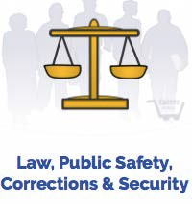  Law, public safety, corrections, and security workers are found in a variety of settings. For example, you might guard the public and this cluster: enforce the law as a police officer or security guard. Or provide fire protection as a firefighter.  12  Other workers provide legal services to people who commit crimes. For example, you might monitor activities within a prison, advise clients of their legal rights, or research legal procedures to support court cases. | There are many hobbies and activities you could explore to learn more about law, public safety, corrections, and security. Try one or more of these activities:  - Mock trial  - Debate  - Work as a page at the legislature.  - Visit a local courthouse or public safety office.  - Volunteer with programs for at-risk youth or ex-offenders.  - Job shadow a lawyer at a legal firm.  - Attend court hearings and other public legal procedures
Great Oaks programs offered in this cluster: Firefighting/Emergency Medical Service; Law Enforcement
Manufacturing workers work with products and equipment. You might design a new product, decide how the product will be made, or make the product. You might work on cars, computers, appliances, airplanes, or electronic devices.  13  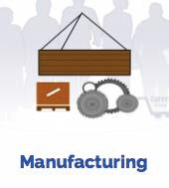  Other manufacturing workers install or repair products. For example, you might install refrigerators or washers, repair plumping in commercial buildings, or diagnose engine problems in cars and trucks. |  | There are many hobbies and activities you could explore to learn more about manufacturing. Try one or more of these activities:  - Skills USA  - Math club  - Do basic repairs on home appliances or electronics  - Visit an auto repair shop.  - Job shadow a machinist.  - Explore apprenticeship opportunities with local companies.  - Participate in local STEM (science, technology, engineering, and math) events.
Great Oaks programs offered in this cluster: Engineering Technologies & Robotics; Precision Machining; Welding;
Project Lead the Way (Satellite offering at specific partner schools)
14  Marketing, sales, and service workers help businesses sell products. You might advertise and promote products so customers want to buy them. Or, you might sell products and services to customers.  For example, you might develop a marketing plan for a small start-up company; sell furniture; or measure and fit lenses and frames for eyeglass customers. |  | There are many hobbies and activities you could explore to learn more about marketing. Try one or more of these activities  - DECA (Marketing association)  - Business Professionals of America (BPA)  - Junior Achievement  - Girl Scouts or Boy Scouts  - Student government  - Help with class fundraisers.  - Join a committee to plan an event.  - Start a small business.  - Design promotional materials for a local business.  - Sell ads for a school newspaper or yearbook.  - Work at a concession stand.  - Work part-time in a retail store, real estate office, or in promotions.  - Read newspapers, magazines, and Web sites to stay current on consumer trends.  - Intern at an advertising, public relations, or market research firm
Great Oaks programs offered in this cluster: Satellite offerings at specific partner schools - Marketing Technology; Marketing Management & Research;
Business Management; High School of Business
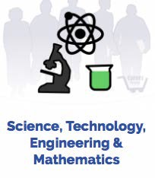  Science, technology, engineering, and mathematics workers do scientific research in laboratories or the field. Others plan or design products and systems. Or, you might support scientists, mathematicians, or engineers as they do their work.  15  For example, you might oversee the construction of roads, develop systems to prevent diseases, or help engineers do research and read blueprints. |  | There are many hobbies and activities you could explore to learn more about science, technology, engineering, and mathematics. Try one or more of these activities:  - Skills USA  - Math Club  - Math Counts  - Science Club  - Prepare a project for a science fair.  - Learn computer applications or technology related to the field, like CAD.  - Job shadow an engineer or scientist.  - Teach youth at a science summer camp or after-school program.
Great Oaks programs offered in this cluster: Engineering Tech & Robotics; Project Lead the Way (Satellite offering at specific partner schools)
16  Transportation, distribution, and logistics workers move people and products by road, air, rail, and water. You might work as a driver, pilot, engineer, or captain.  You might repair or maintain the vehicles, trains, planes, and ships that move people and products. Or, you might work behind the scenes to make sure the products and people get to the right place on time. |  | There are many hobbies and activities you could explore to learn more about transportation, distribution, and logistics. Try one or more of these activities:  - Skills USA  - Car shows  - Visit an auto repair shop  - Design, paint or work on cars  - Read trade publications to stay current on economic and political issues affecting transportation.  - Job shadow a transportation manager or dispatcher.  - Intern at a local garage or motorcycle shop to learn the basics of auto or small engine repair.  - Travel
Great Oaks programs offered in this cluster: Automotive Collision; Automotive Mechanics; Aviation Maintenance Technician; Industrial Diesel Mechanics

Disclaimer: Your interests will probably change over time. These survey results are intended to assist you with informal career exploration. Consider more formal assessments and other resources or services to help you plan your career. This survey does not make any claims of statistical reliability.
Note: This survey does not make any claims of statistical reliability and has not been normed. It is intended for use as a guidance tool to generate discussion regarding careers and is valid for that purpose.

My Results

My top three Career Clusters of interest are:
1.
2.
3.

Think about your career goals.
Make a list of careers you find interesting right now:

Create your first career goal. This is simply your idea of what you want to accomplish.
sample career goals: My goal is to help sick people get better or I plan to start a business that will change the world.

What classes might be helpful for you to take in high school?
What activities or opportunities outside of school can you pursue to help you with your career goals?
What will you need to do after high school?
What degree, certification, license or training will you need?
Career Steps to Take in High School

- Check out what's happening in high school - there are classes to get you ahead in the career field or occupation you're interested in. You just have to be in the know! Select classes in high school based on the requirements that you'll need to be college and career ready. It’s the time to start preparing for your career. The more you learn about the working world, the easier it is to know where you want to go.

- Check out Ohio Department of Education Career Connections Pathways for various career clusters to get hints on what high school classes match your career choice:
http://education.ohio.gov/Topics/Career-Tech/Career-Connections/Career-Pathways

- Try on a career with Career and Technical Education. There are many jobs that you can explore while you’re in high school through a Career and Technical Education (CTE) class. Dig deeper into the career of your choice and expand your options. CTE translates into:
  - Opportunity to be trained by highly-qualified instructors on the latest state-of-the-art equipment and technology.
  - Opportunity to make valuable connections with professionals in business and industry.
  - Opportunity for students to apply their newly-minted knowledge and skills by working on challenging real-world projects in the field, outside the classroom.
  - Opportunity to grasp and utilize academic concepts in actual, career- related situations.
  - Opportunity to hone the ability to think critically and to problem-solve.
  - Opportunity to sharpen the necessary “soft skills” that greatly heighten a candidate’s employability like punctuality, functioning as part of a team, being prepared with the proper gear and attire, and having the confidence and know-how to interact with the public and with colleagues in a professional manner.

These days, the program offerings at career tech high schools aren’t limited to time-tested staples like automotive, construction and graphics. Now, students can also choose cutting-edge career paths in engineering, robotics, criminal justice, web applications and computer technology. Even in areas like automotive, for instance, students’ training incorporates the most up-to-date advances in sophisticated new technology that are used in today’s vehicles. So, if you ever thought about becoming a nurse or pharmacist? Or maybe you like working with technology or enjoy sales and marketing. Do you like welding or carpentry? Whether your passion is for cooking, learning to build robots, or helping people get healthy, career tech is a way to explore those interests in-depth. You can get experiential, specialized training. Often, you’re able to earn industry certification and college credits while you’re still in high school. Plus, you add value to your resume, for when you start looking for a job

Ask which CTE classes are available at your high school or middle school.

